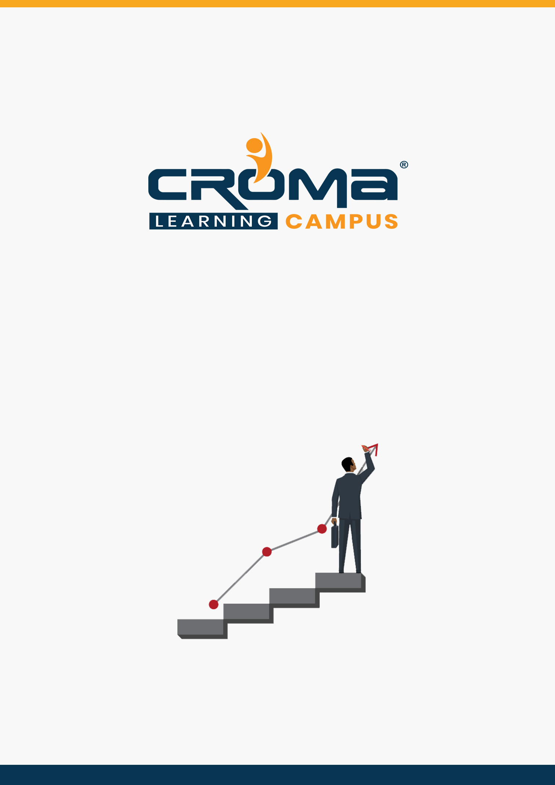

**AZ-304 Microsoft Azure Architect Design Training Curriculum**

**STRUCTURE**

**www.cromacampus.com | helpdesk@cromacampus.com | +91-120-4155255**

**AZ-304 Microsoft Azure Architect Design Training Curriculum**

*“Learn translating complex business requirements into reliable and scalable cloud solutions with our detailed Curriculum for AZ 304 Certification Training”*

**Course Objectives:**

* Prepare yourself for the certification exam and clear your certification exam in the first attempt
* Add an attractive credential in your resume that is really appreciated by Companies.
* Improve your overall Cloud management skills, azure development skills, solution designing, implementation skills, and explore more job prospects with better salary packages.
* Boost your social media profiles especially LinkedIn by adding this certification and become one of the top persons to be chosen by industries.

**AZ 304 Certification Training Description:**

The job role and responsibilities for an Azure Solution Architect include advising stakeholders and translating business requirements into secure, scalable, and reliable cloud solutions. Also, an Azure Solution Architect partners with cloud administrators, cloud DBAs, and clients to implement solutions.

After joining our Training program at Croma Campus, you will gain subject matter expertise in designing and implementing solutions that run on Microsoft Azure, including aspects like compute, network, storage, and security.

***Here are some strong reasons why should you consider this certification course.***

* Validate your technical skills like storage, networking, compute, security, and other Cloud operations on Microsoft Azure.
* Validate your solution designing and architect skills by successful implementation of cloud solutions at the workplace.
* Top-paying info-tech certification in the world.
* It provides you with global recognition for your knowledge, skills, and experience.
* The organization looks for those who know Oracle Cloud, AWS, Azure, etc.

**Prerequisites for the Certification Exam:**

A candidate for this exam should have advanced experience and knowledge across various aspects of IT operations, including networking, virtualization, identity, security, business continuity, disaster recovery, data management, budgeting, and governance–this role should manage how decisions in each area affect an overall solution.

In addition, this role should be proficient in at least one of these Azure knowledge domains: AZ 103 administration, AZ 203 development, or DevOps.

**Necessary Details about Certification You must Know**

* Certification Name – AZ-304 Microsoft Azure Architect Design
* Exam Duration: 150 minutes
* Number of Questions: 40-60
* Passing score: 700 (Out of 1000)
* Exam Cost: USD 165.00
* Validity: 2 years

**Certification Exam Structure:**

* Design monitoring (10-15%)
* Design identity and security (25-30%)
* Design data storage (15-20%)
* Design business continuity (10-15%)
* Design infrastructure (25-30%)

**Course Content:**

**Module 1: Design Monitoring (10-15%)**

**Design for cost optimization**

* recommend a solution for cost management and cost reporting
* recommend solutions to minimize costs

**Design a solution for logging and monitoring**

* determine levels and storage locations for logs
* plan for integration with monitoring tools including Azure Monitor and Azure Sentinel
* recommend appropriate monitoring tool(s) for a solution
* choose a mechanism for event routing and escalation
* recommend a logging solution for compliance requirements

**Module 2: Design Identity and Security (25-30%)**

**Design authentication**

* recommend a solution for single-sign on
* recommend a solution for authentication
* recommend a solution for Conditional Access, including multi-factor authentication
* recommend a solution for network access authentication
* recommend a solution for a hybrid identity including Azure AD Connect and Azure AD Connect Health
* recommend a solution for user self-service
* recommend and implement a solution for B2B integration
* NOT: federation with ADFS or PingFederate

**Design authorization**

* choose an authorization approach
* recommend a hierarchical structure that includes management groups, subscriptions and resource groups
* recommend an access management solution including RBAC policies, access reviews, role assignments, physical access, Privileged Identity Management (PIM), Azure AD Identity Protection, Just in Time (JIT) access

**Design governance**

* recommend a strategy for tagging
* recommend a solution for using Azure Policy
* recommend a solution for using Azure Blueprint
* recommend a solution that leverages Azure Resource Graph

**Design security for applications**

* recommend a solution that includes KeyVault
  + What can be stored in KeyVault?
  + KeyVault operations
  + KeyVault regions
* recommend a solution that includes Azure AD Managed Identities
* recommend a solution for integrating applications into Azure AD

**Module 3: Design Data Storage (15-20%)**

**Design a solution for databases**

* select an appropriate data platform based on requirements
* recommend database service tier sizing
* recommend a solution for database scalability
* recommend a solution for encrypting data at rest, data in transmission, and data in use

**Design data integration**

* recommend a data flow to meet business requirements
* recommend a solution for data integration, including Azure Data Factory, Azure Data Bricks, Azure Data Lake, Azure Synapse Analytics

**Select an appropriate storage account**

* choose between storage tiers
* recommend a storage access solution
* recommend storage management tools

**Module 4: Design Business Continuity (10-15%)**

**Design a solution for backup and recovery**

* Recommend a recovery solution for Azure hybrid and on-premises workloads that meets
* Recovery objectives (RTO, RLO, RPO)
* Design an Azure Site Recovery solution
  + recommend a site recovery replication policy
  + recommend a solution for site recovery capacity
  + recommend a solution for site failover and failback (planned/unplanned)
  + recommend a solution for the site recovery network
  + recommend a solution for recovery in different regions
  + recommend a solution for geo-redundancy of workloads
  + recommend a solution for Azure Backup management
* Design a solution for data archiving and retention
  + recommend storage types and methodology for data archiving
  + identify business compliance requirements for data archiving
  + identify requirements for data archiving
  + identify SLA(s) for data archiving
  + recommend a data retention policy

**Design for high availability**

* recommend a solution for application and workload redundancy, including compute, database, and storage
* recommend a solution for autoscaling
* identify resources that require high availability
* identify storage types for high availability

**Module 5: Design Infrastructure (25-30%)**

**Design a compute solution**

* recommend a solution for compute provisioning
* determine appropriate compute technologies, including virtual machines, App Services,
* Service Fabric, Azure Functions, Windows Virtual Desktop, Batch, HPC and containers
* recommend a solution for containers
* AKS versus ACI and the configuration of each one
* recommend a solution for automating compute management

**Design a network solution**

* recommend a network architecture (hub and spoke, Virtual WAN)
* recommend a solution for network addressing and name resolution
* recommend a solution for network provisioning
* recommend a solution for network security including private Link, firewalls, gateways, network segmentation (perimeter networks/DMZs/NVAs)
* recommend a solution for network connectivity to the Internet, on-premises networks, and other Azure virtual networks
* recommend a solution for automating network management
* recommend a solution for load balancing and traffic routing

**Design an application architecture**

* recommend a microservices architecture including Event Grid, Event Hubs, Service Bus, Storage Queues, Logic Apps, Azure Functions, Service Fabric, AKS, Azure App Configuration and webhooks
* recommend an orchestration solution for deployment and maintenance of applications including ARM templates, Azure Automation, Azure Pipelines, Logic Apps, or Azure Functions
* select an automation method
* choose which resources or lifecycle steps will be automated
* design integration with other sources such as an ITSM solution
* recommend a solution for monitoring automation
* recommend a solution for API integration
* design an API gateway strategy
* determine policies for internal and external consumption of APIs
* recommend a hosting structure for API management
* recommend when and how to use API Keys

**Design Migrations**

* assess and interpret on-premises servers, data, and applications for migration
* recommend a solution for migrating applications and VMs
* recommend a solution for migration of databases
* determine migration scope, including redundant, related, trivial, and outdated data
* recommend a solution for migrating data (Storage Migration Service, Azure Data Box, Azure File Sync-based migration to hybrid file server)

**Module 6: Placement Guide**

* Tips to clear an Interview
* Common Interview questions and answers
* AZ 304 Interview Questions and Answers
* Resume Building Guide
* Attempt for AZ 304 Global Certification Exam
* Start applying for Jobs